**Philemon Ondigo. SCCI/01152/2019**

**FOR: AN EXPENSE MANAGEMENT SYSTEM (SMS|ESMS|esmes)**

Project Scope

October 29th, 2022

# **Overview**

## **Project Background and Description**

SMS is an **Expense**(Spending) **Management System** that allows end-users of the system to be able to keep track of their day-to-day expenses, keep track of their weekly, monthly or annual expenditure an know where their they spend most of their finances on ranging from either Shopping, Rent, Investments etc.

Keeping track of your day-to-day expenditure is quite difficult or rather cumbersome and for one to keep track of how they spent every e-coin on a single day, they have to sit down go through their M-Pesa messages and/or Bank messages they have on their smartphones for that particular day and count each of them manually then have to store that info either on their brain or on some short note book or transfer it to an excel spreadsheet. This experience is quite tedious and one may only do that for a short period of time before getting bored doing all that. That where SMS|ESMS|esmes come into play.

### Elaborator

## **Project Scope**

In order to achieve the above named, the project will be implemented as a compatible mobile application that will be downloadable from majority of the app stores. The mobile application once downloaded should be able to:

* (First time only) Prompt the user to **Create** an **Account** using a **Phone-Number** or **Email-Address** and a **Password**.
* Allow the user to **Login** into the app using the information specified above (Note: It will be a one-time login unless user clears app data).
* (First time only) After login, the user should be prompted to give permission to access **Messaging Service**, **Notification**, **Storage** etc.
* Enable the user to create categories of expenses i.e., groceries, clothing, airtime, rent, partying etc. This naming convention is as per user preference i.e.; users can name the categories what they want. (These categories can be nested.)
* Enable users to add the messages from the message pool to these categories.
* Send push notification to the user asking whether the new message should be added into the message pool or ignored.

### **C Diagram**

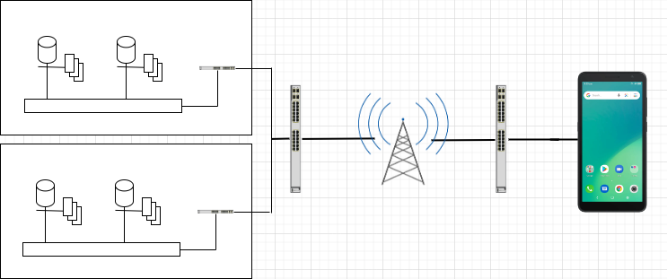

### **Modules**

#### **Membership Module**

Allows members to create an account using their Phone-Numbers/Emails and passwords. Then allows members to login into the app using the same credentials. This module also enables users to update their profiles i.e., add profile photo, manage password, logout of account etc.

#### **Expenditure Module**

This is used to retrieve the user’s expenditure information from the database and display it on the homepage. These will display the premade categories and options to add or remove a category, a link to the message pool etc.

#### **Alert Module**

This module will be responsible for getting all new messages from the messaging app and pushing it to the message pull and handling of the push notification and alerts displayed to the user.

#### **Reports Module**

This module will be responsible for de-structuring the message from the categories and getting all the necessary information from every single message then be able to perform the calculations before displaying the results on the cards in the users main screen where users can see their expenditure.

## **High Level Requirements**

The system is implemented as a mobile application at the moment but will be integrated into tablet, web and desktop application as it progresses, thus any device with internet access can be able to access it from their app store.

The mobile application must be able to:

* Incorporate automated routing and notifications based on user specification.
* Enable users to provide access to what is to be saved and what to be ignored.
* Allow users to customize the display based on their preferences.

## **Deliverables**

* Back-end software that is to be hosted on the cloud.
* UI prototype for the mobile application.
* User documentation manual.
* Technical documentation.

## **Specific Exclusions from Scope**

In this version/phase 1 the following will be excluded and will come with subsequent phases: -

* Ability to export the duration expenses into a datasheet file i.e., excel etc.
* Ability to be able to work offline i.e., it will require internet connection in order to perform computations since the system is hosted on cloud servers.
* Ability to check for spam messages i.e., scammer sending message similar to an M-Pesa message.
* Ability to detect organization used in the transfer of funds.